**Linux Tasks**

1. **Create user with name Techie and provide sudo access to user.**

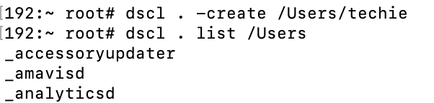

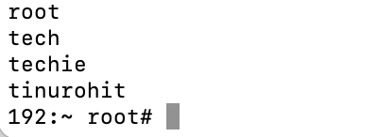

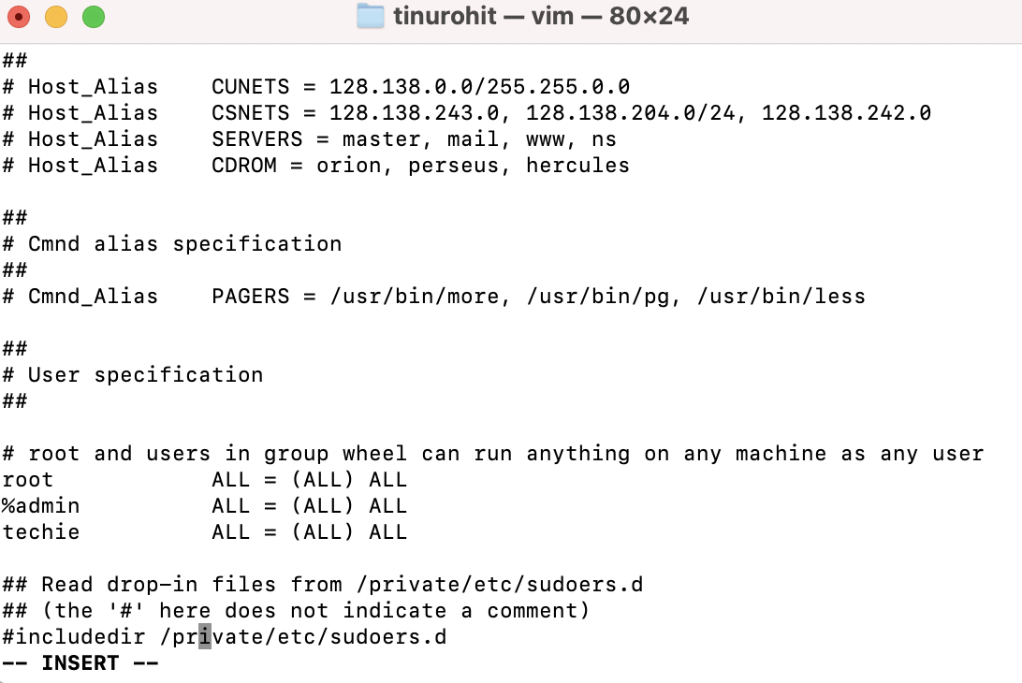

1. **Navigate to the home directory.**



1. **Create a new directory.**

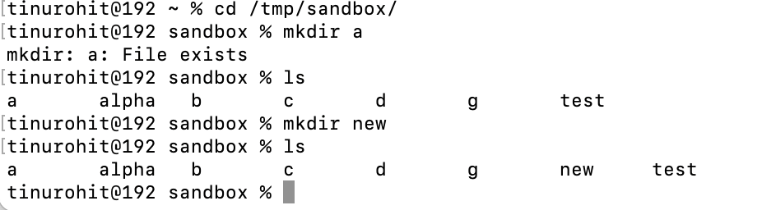

1. **List the contents of a directory.**

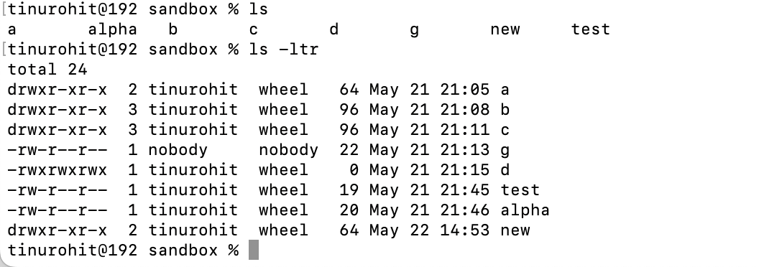

1. **Change the current directory.**

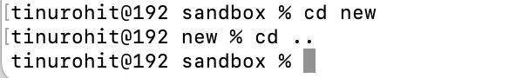

1. **Create a new empty file.**

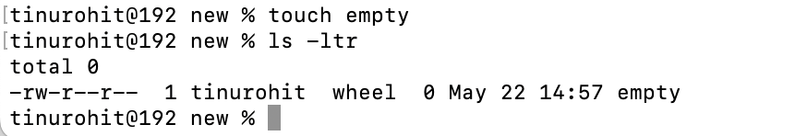

1. **View the contents of a file.**

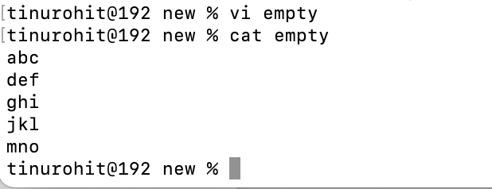

1. **Copy a file to another location.**

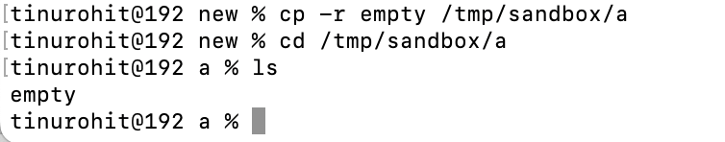

1. **Move a file to another location.**

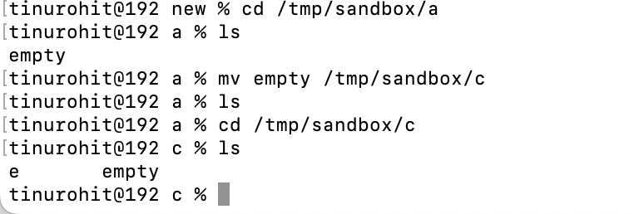

1. **Rename a file.**

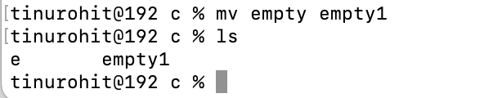

1. **Delete a file.**



1. **Grant or revoke permissions on a file or directory.**

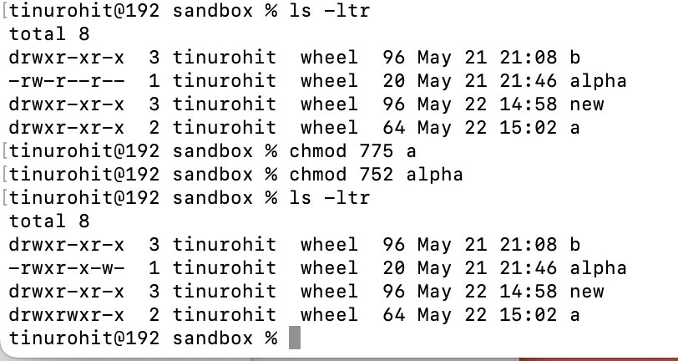

1. **View the current date and time.**

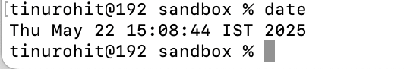

1. **Check the system uptime.**



1. **View the running processes.**

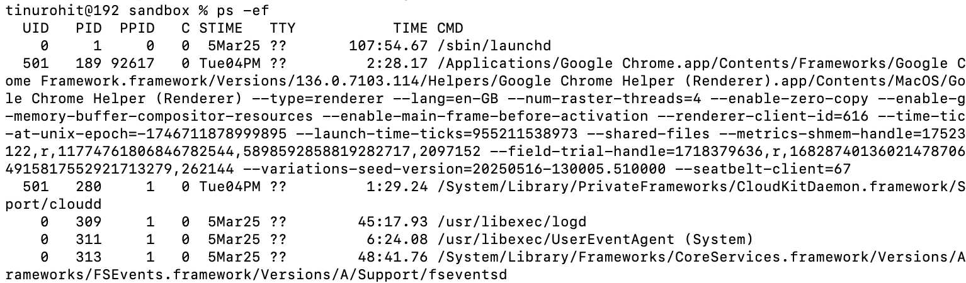

Searched nginx

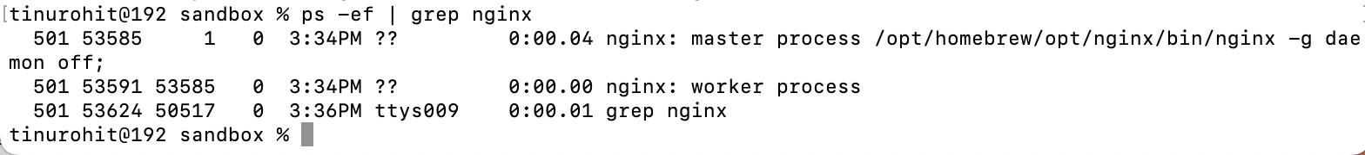

1. **Kill a running process.**

Firstly, started service

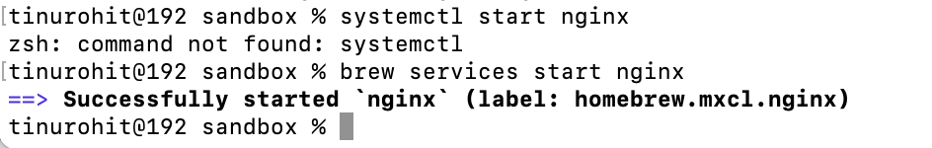

Next, view if it’s running



Using PID num kill the process

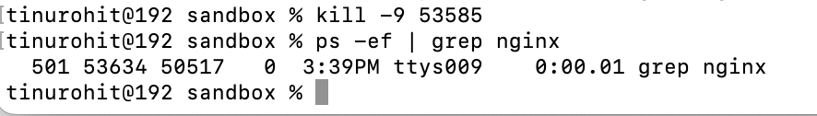

1. **Install a package using the package manager (e.g., apt or yum).**

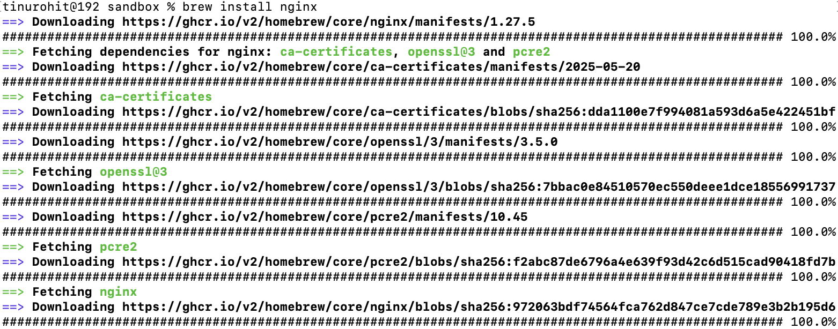

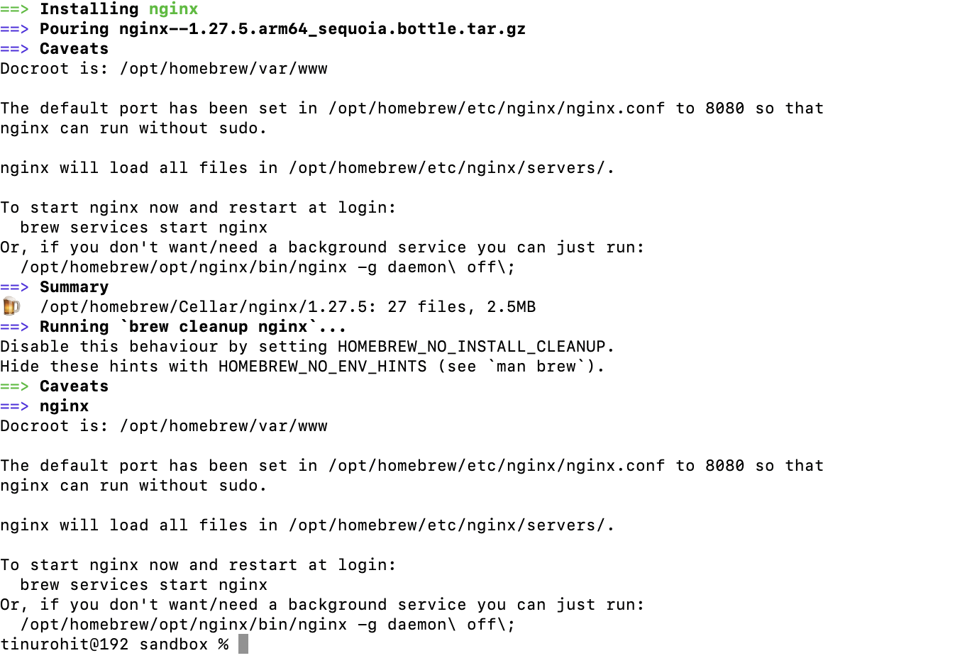

1. **Update the system packages.**

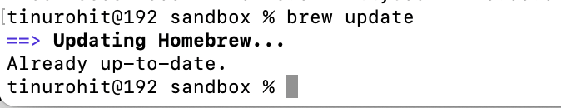

1. **Create a symbolic link.**

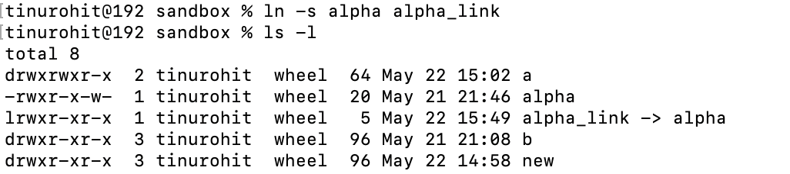

1. **Search for files using the find command.**



1. **Compress and decompress files using tar.**

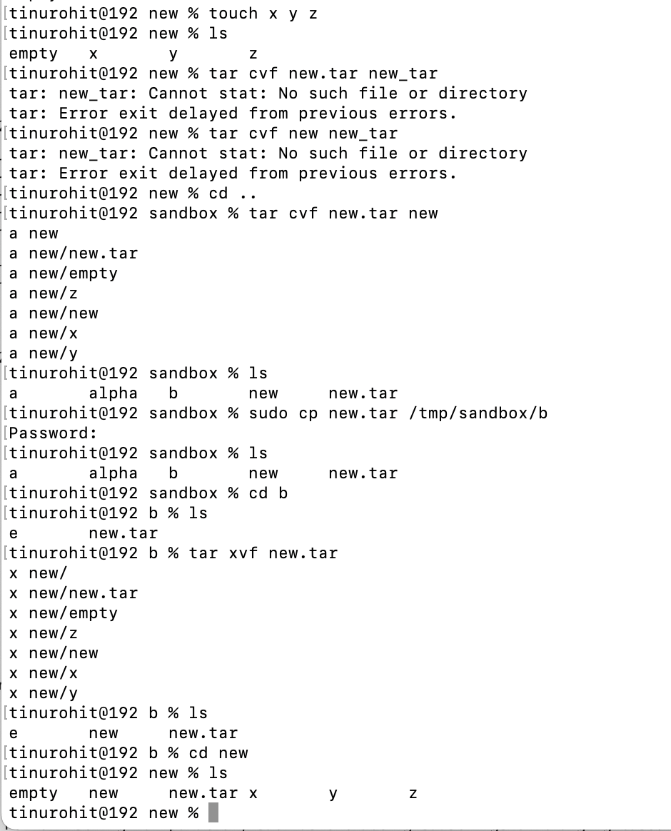

1. **Monitor system resources with top or htop.**

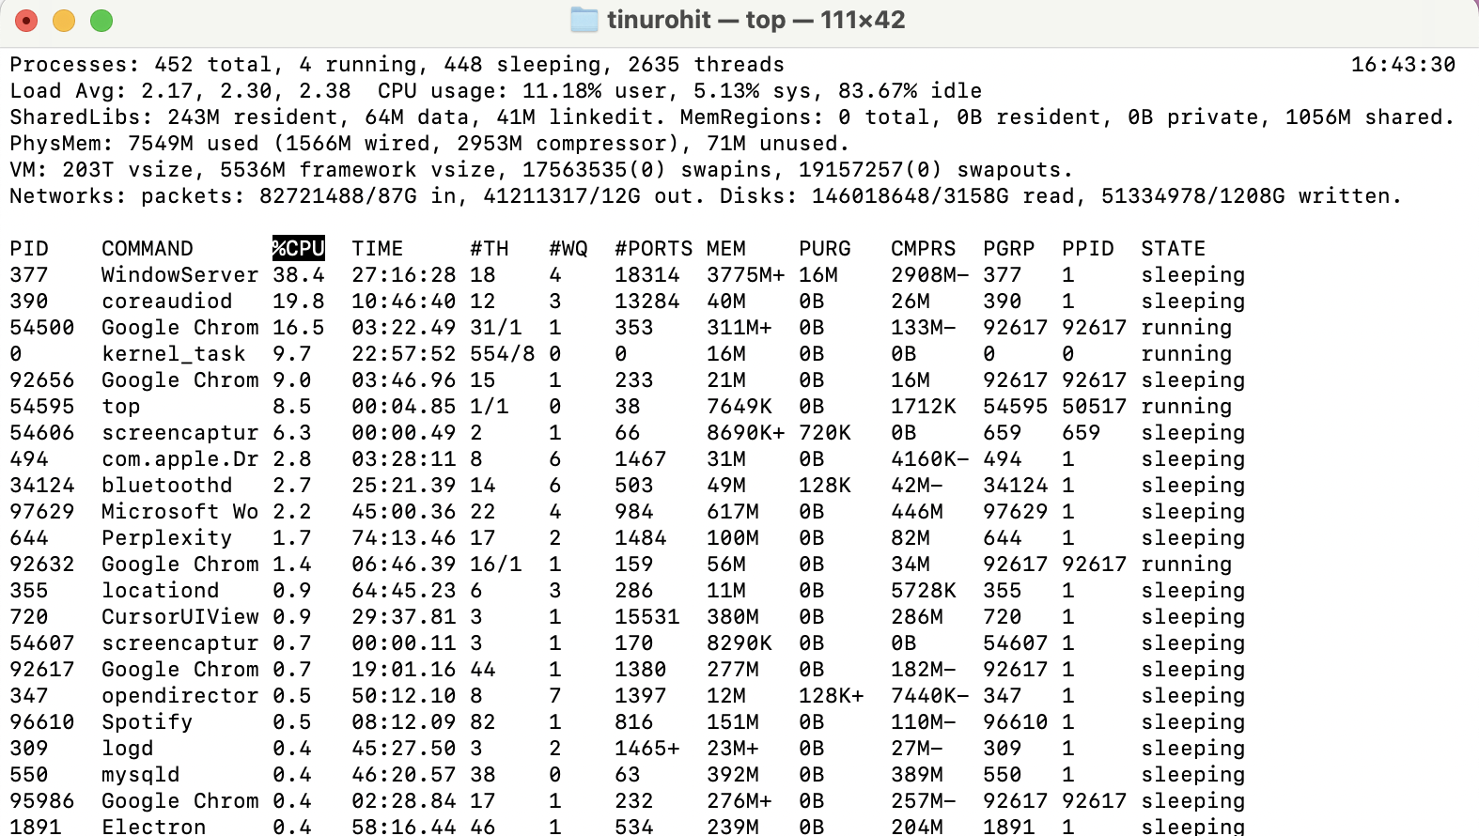

1. **Create and manage user groups.**

**Created group devgroup**



Verify group

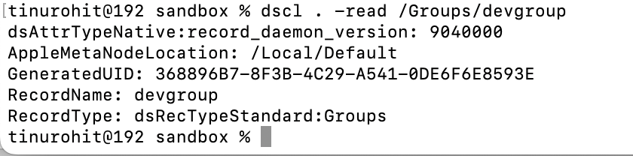

**Adds a user to the group**

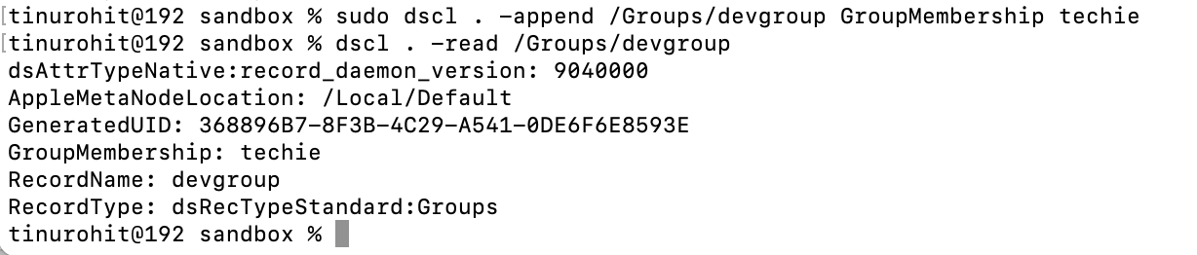

**Deletes a user from the group**

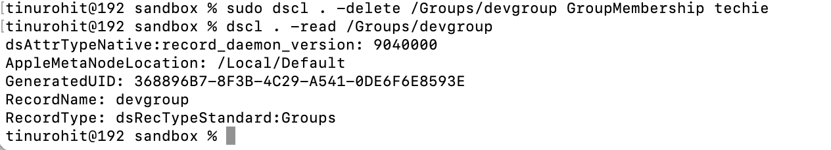

1. **Set up SSH password less authentication.**

Using ssh-keygen generated private and public keys, copied the generated public key to ssh location

In local machine after generating key   
cat ~/.ssh/id_rsa.pub

In ec2 :

mkdir -p ~/.ssh  
chmod 700 ~/.ssh  
nano ~/.ssh/authorized_keys

chmod 600 ~/.ssh/authorized_keys

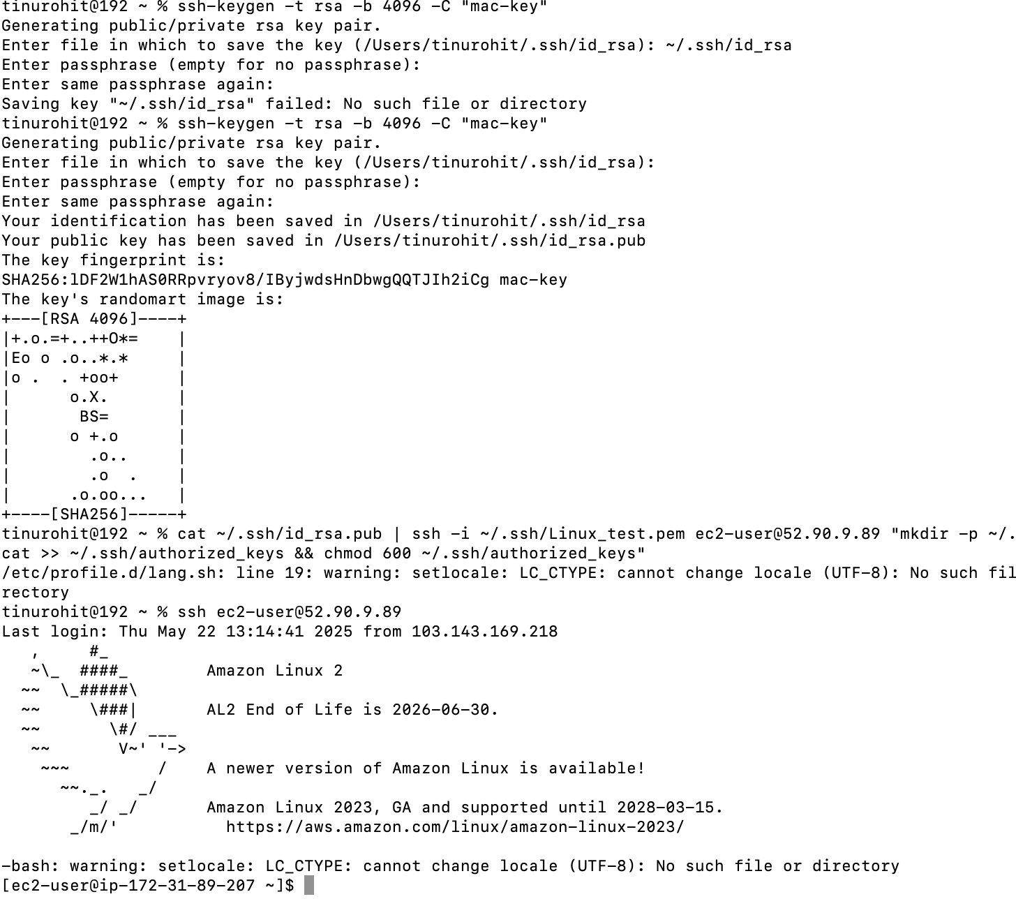

1. **Monitor log files using tail or grep.**

using tail -f filename

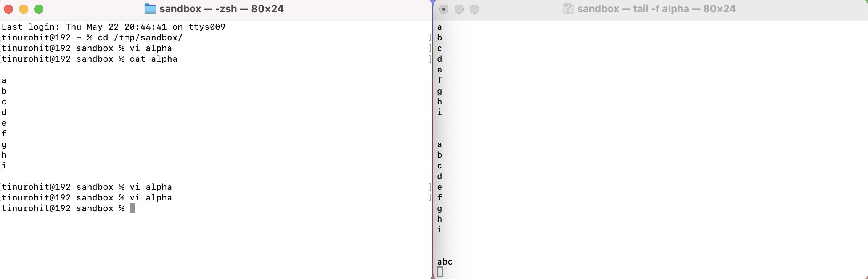

1. **Set up a web server (e.g., Apache or Nginx).**

Installed httpd

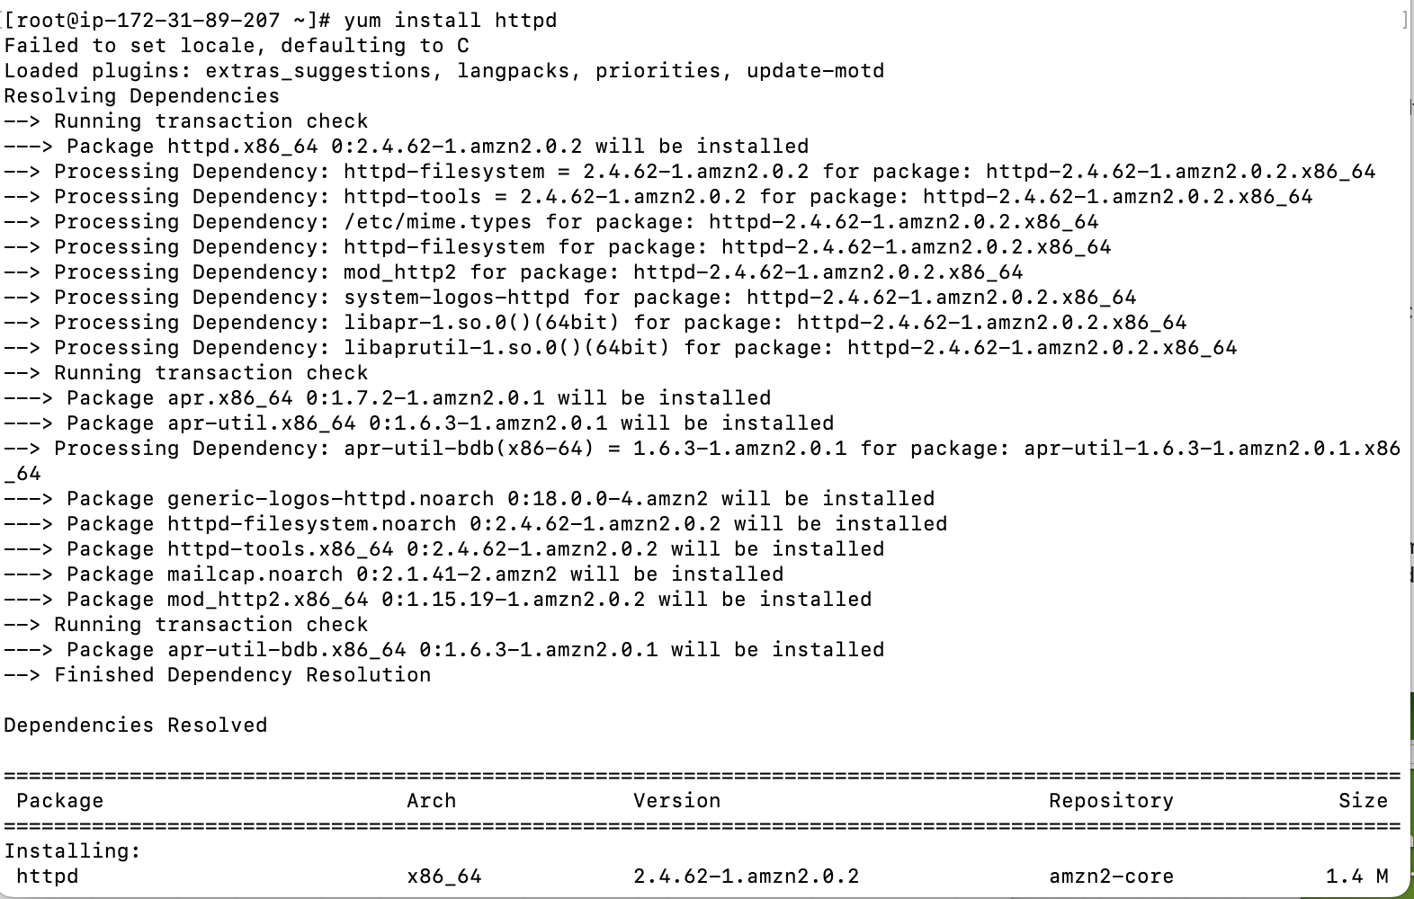

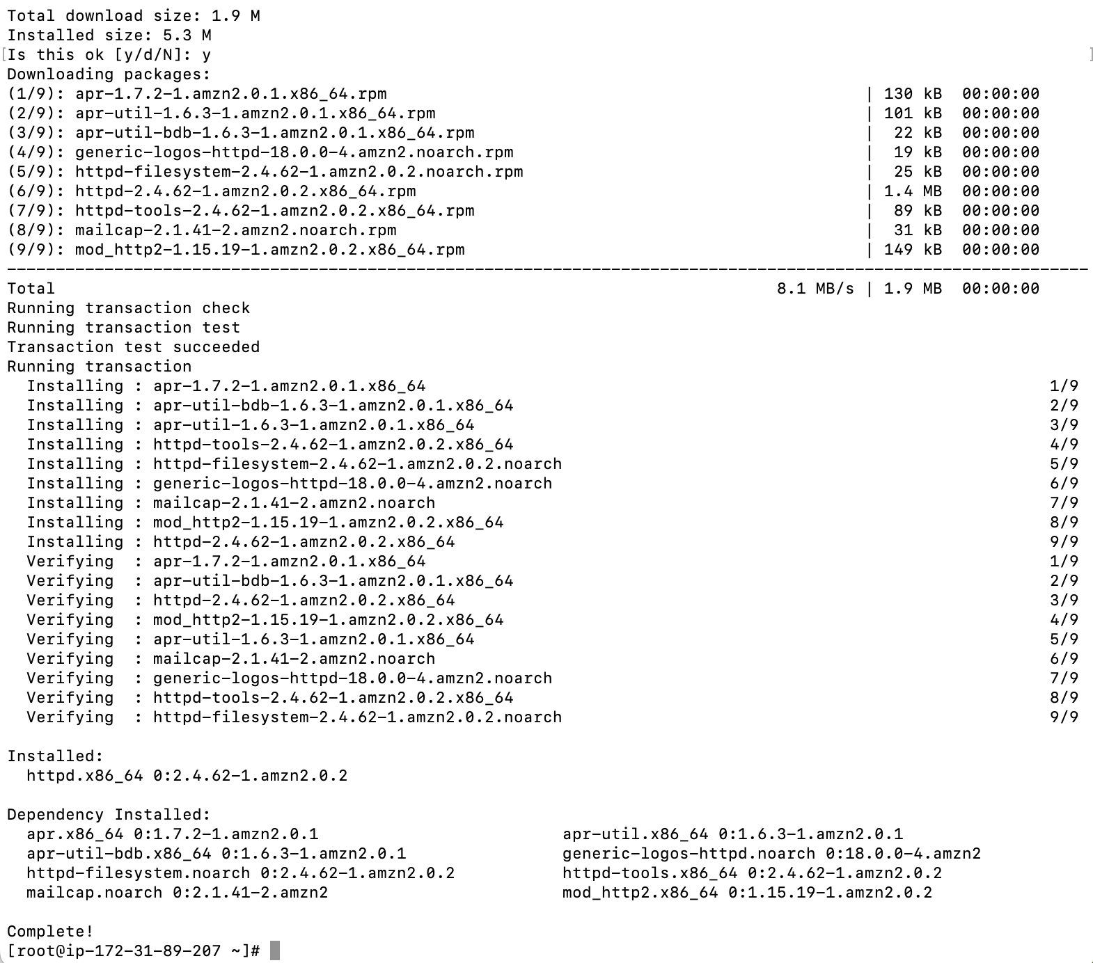



**Installed nginx**

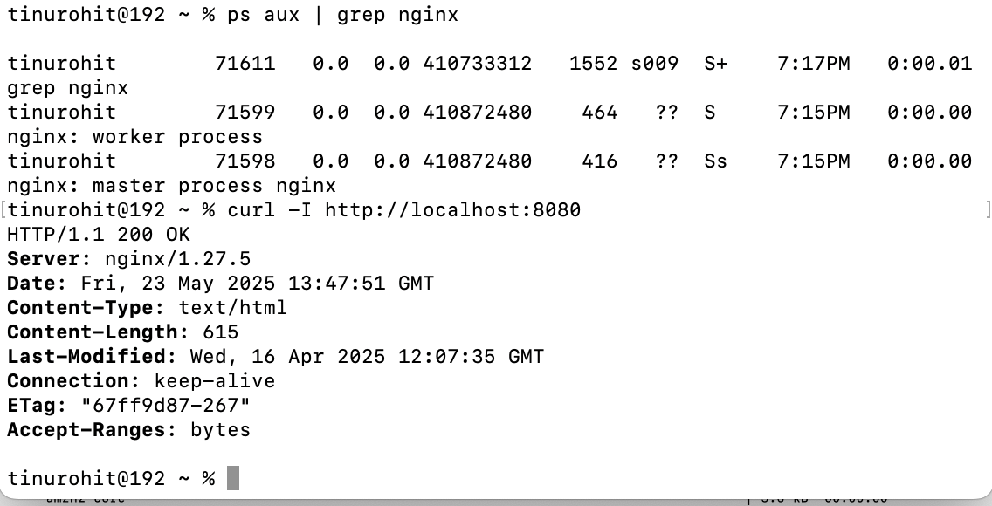

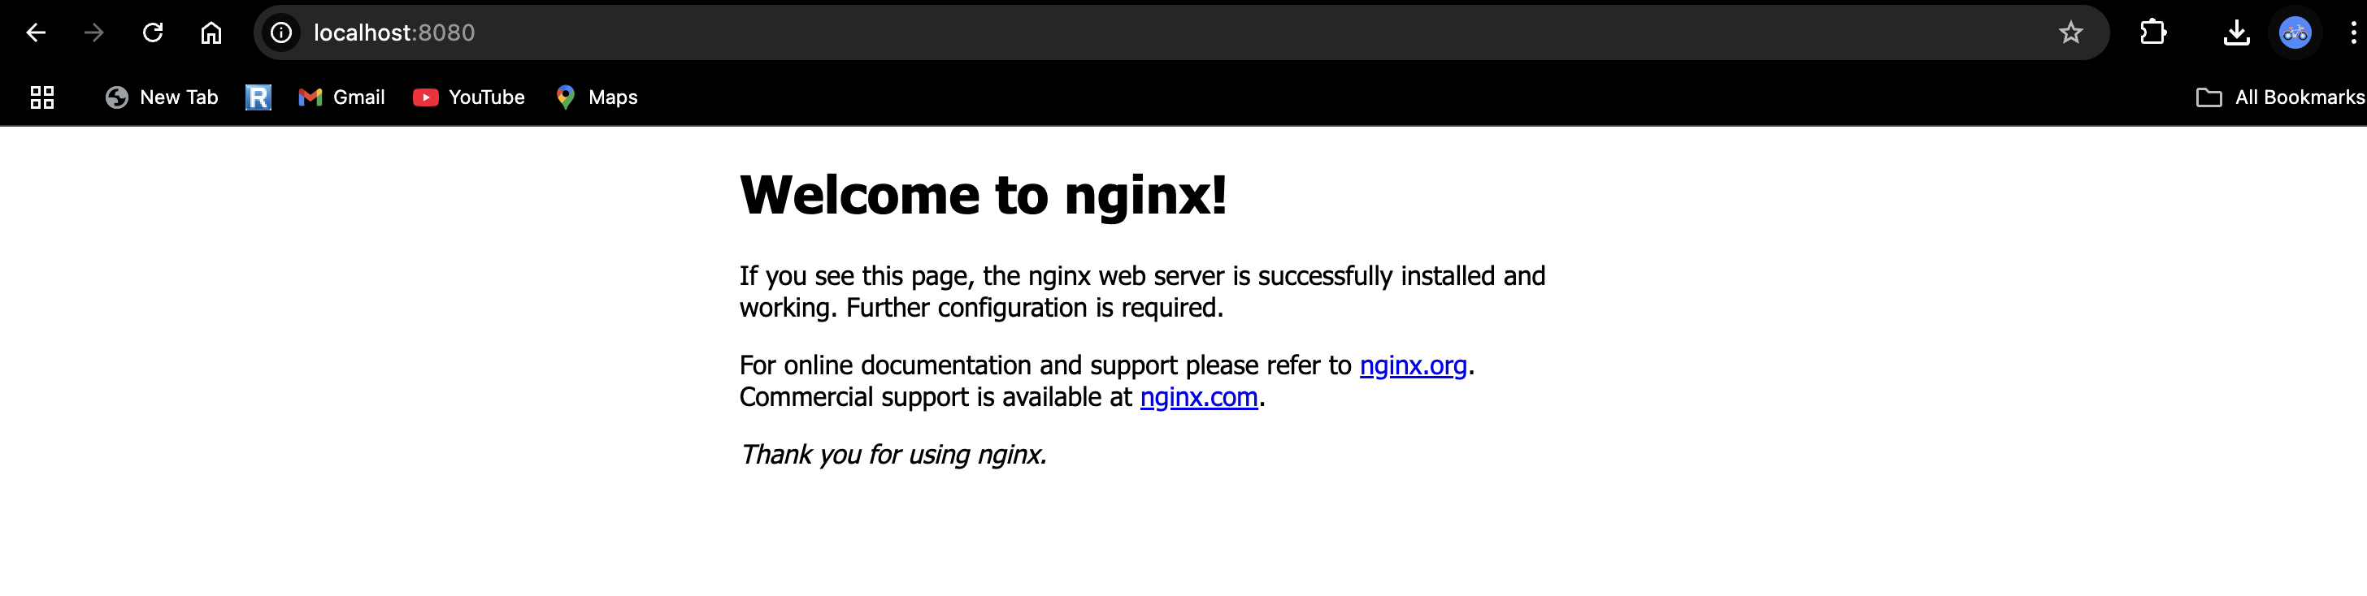

1. **Configure and secure a MySQL Database.**

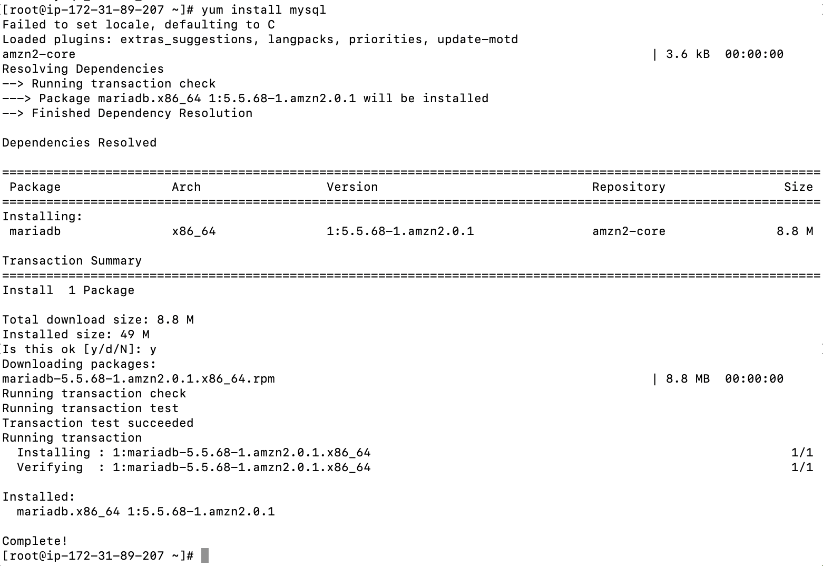

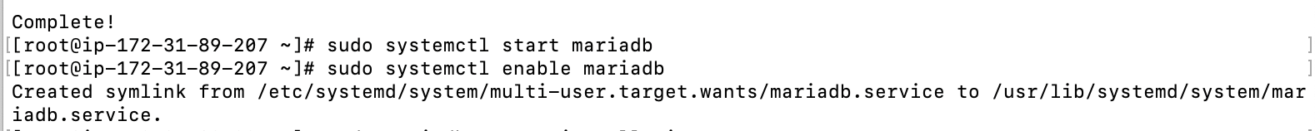



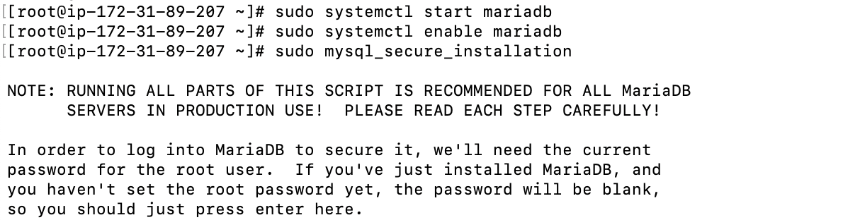

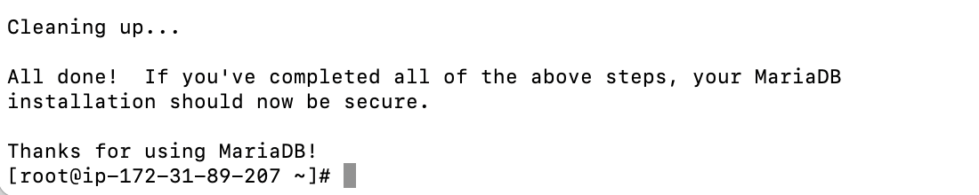

1. **Set up a Application Server (e.g.,Apache Tomcat)**

Install Apache Tomcat and extract tomcat archive

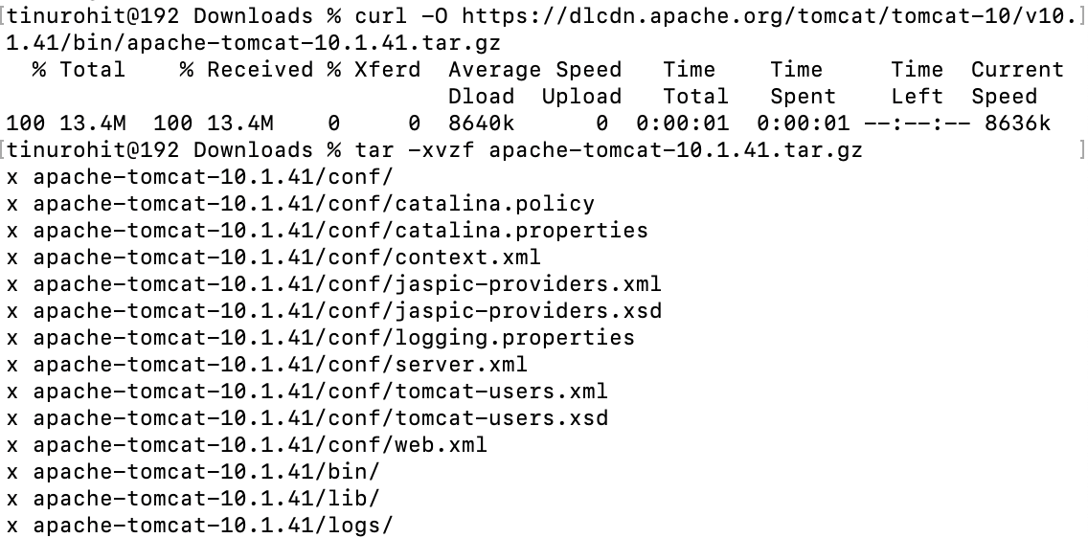

Set environment variables



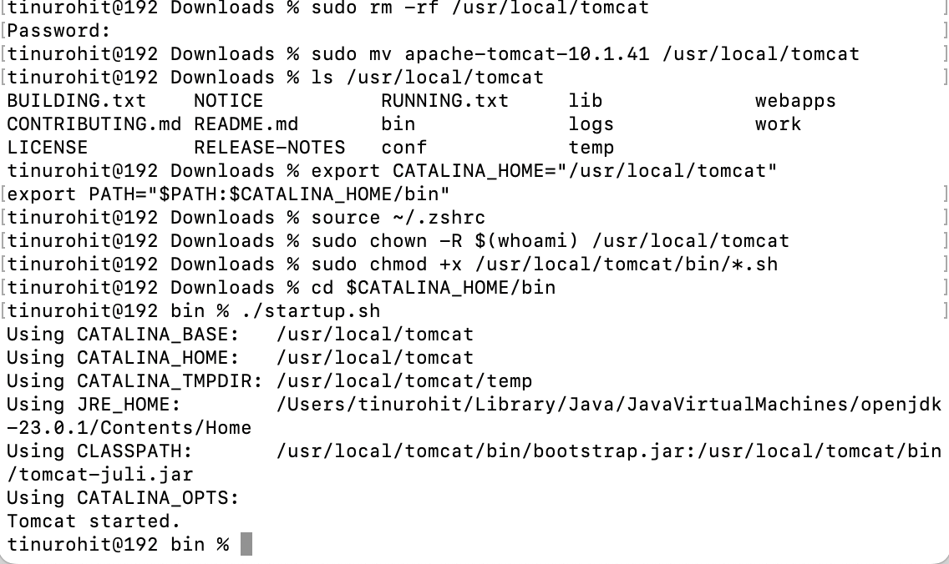

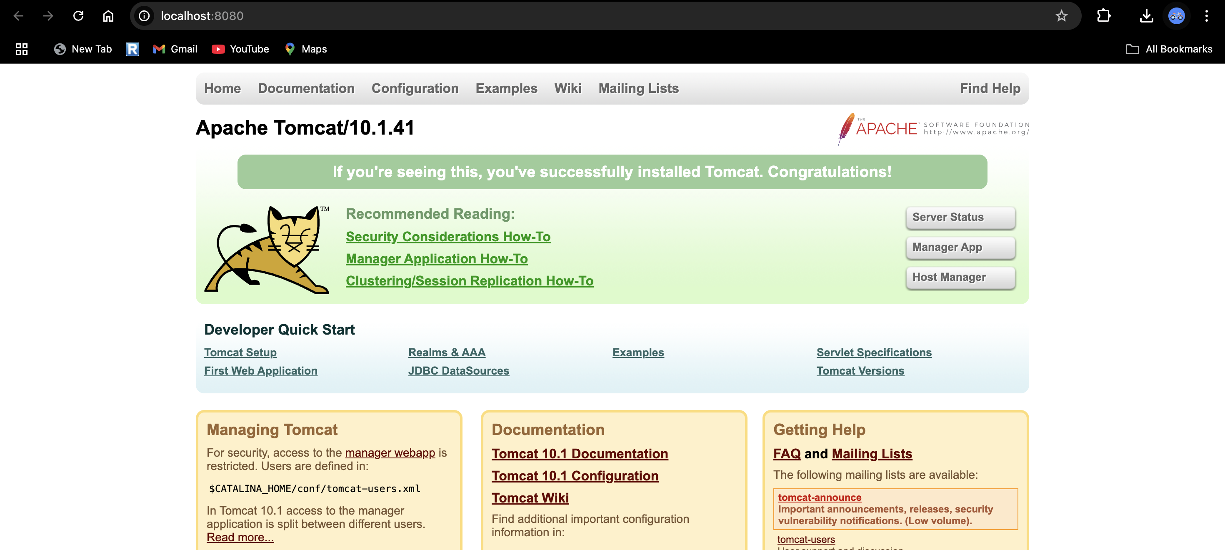

1. **create a service file for Apache Tomcat.(Should execute by using systemtctl command)**
2. to create service file (a.k.a launch agent to manage and control service),
3. create plist file
4. use nano to edit
5. launch using launchctl start
6. check using ps aux | grep tomcat

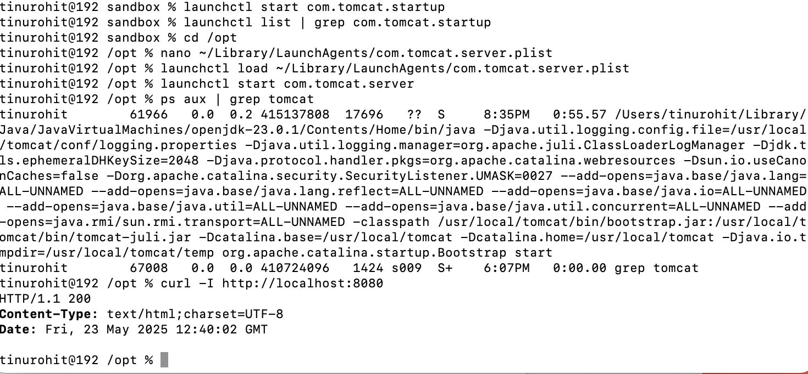

1. **Print specific columns from a delimited file.**

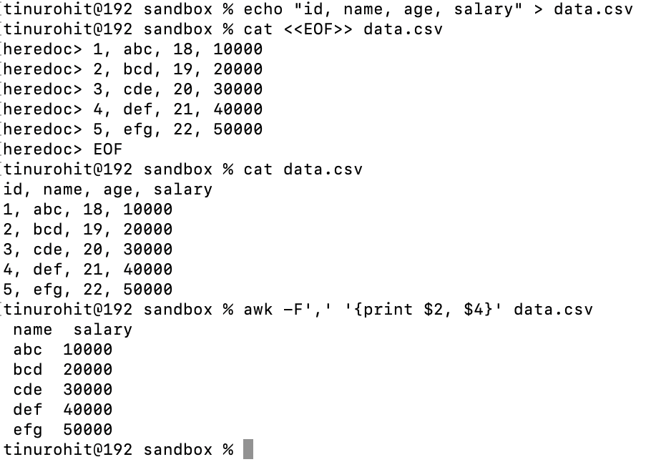

**-F here tells awk what character separates fields, here “,”**

1. **Filter and print lines based on a specific pattern or condition.**

**Condition is salary > 20000**

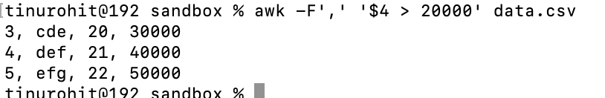

1. **Calculate and print the average, sum, or other statistics of a column.**

**SUM:**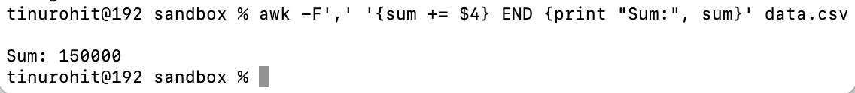

**AVERAGE:**



**MINIMUM:**



**MAXIMUM:**



1. **Perform string manipulation, such as extracting substrings or changing case.**

Print substring of name of first 3 lines and also changing them to uppercase

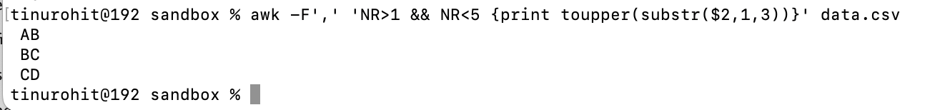

1. **Count the occurrences of a specific pattern in a file.**

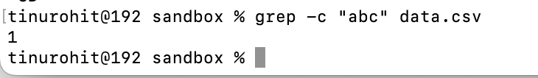

-c : count

1. **Sort lines based on a specific field or column.**

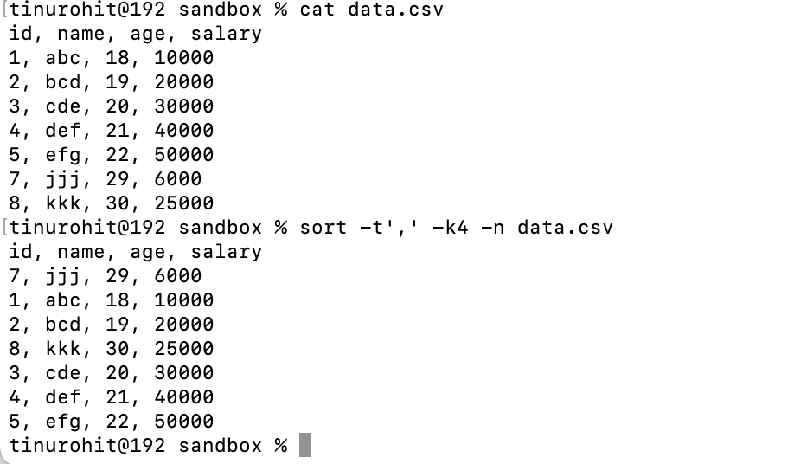

Sort: sorting command

-t’,’ : sets comma as delimeter

-k4 : sort by 4th column

-n : sort numerically

1. **Merge multiple files based on a common field or column.**

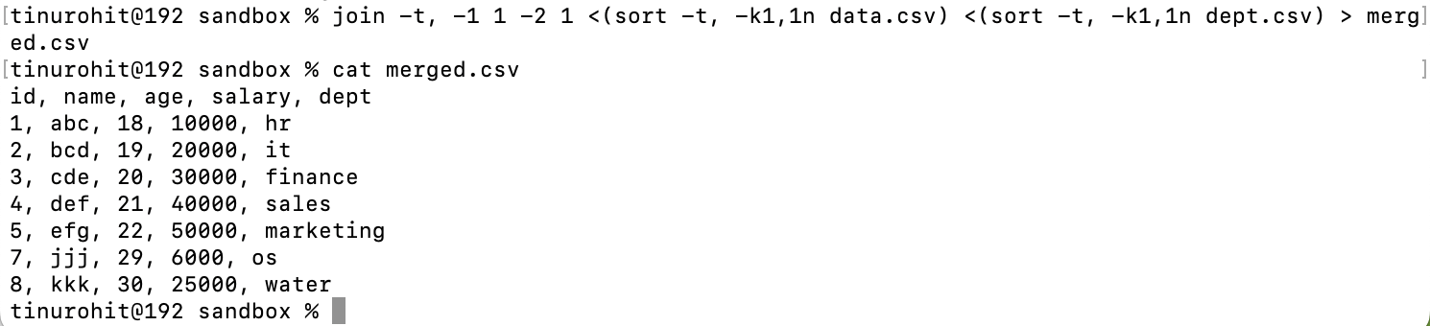

-t : tells join that fields are separated by ,

-1 1: use first field from data.csv

-2 1: use second field from dept.csv

1. **Substitute text in a file using search and replace.**

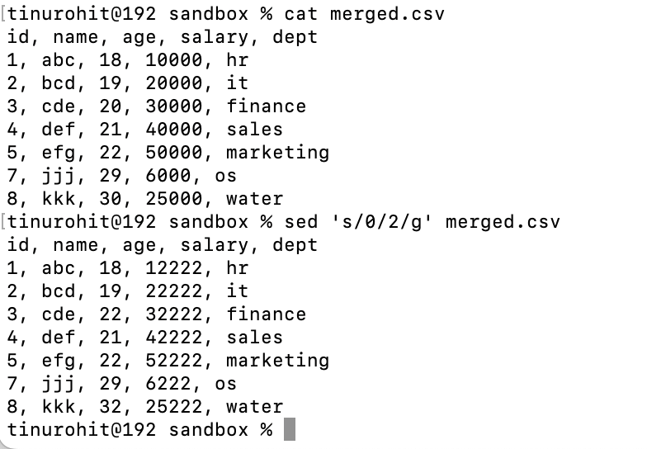

1. **Delete specific lines based on a pattern or line number.**

Delete 3rd row  
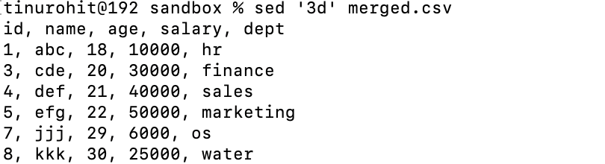

Delete pattern where marketing is present

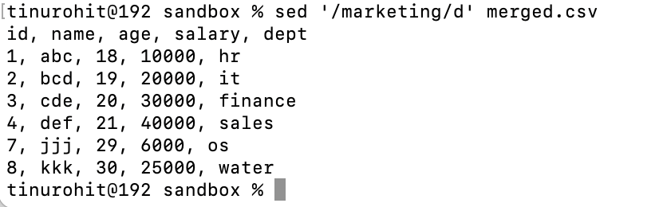

1. **Append or insert text before or after a specific pattern or line.**

After line

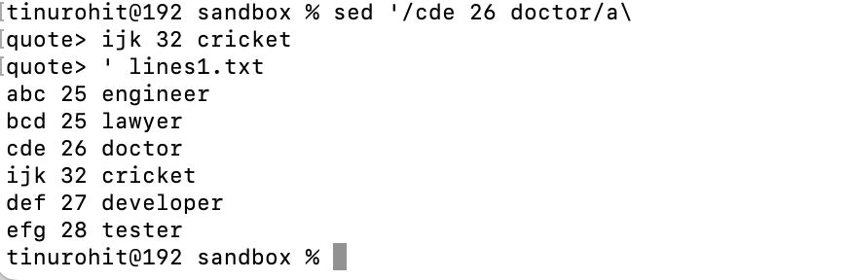

Before line

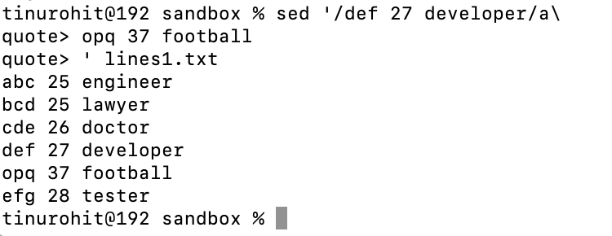

1. **Print only specific lines from a file.**

Print lines from 2 to 5

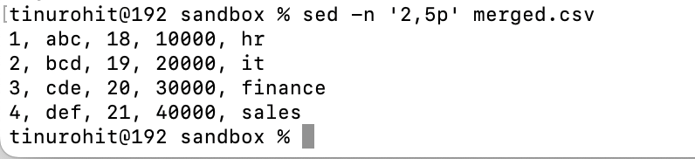

1. **Copy file from linux to windows machine**

**First send a file from local to ssh**



**Send a file from remote connectivity to local**

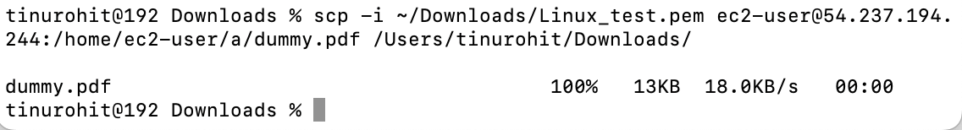

1. **5 use cases for AWK and 5 use cases for sed**

**AWK:**

1. Print specific columns

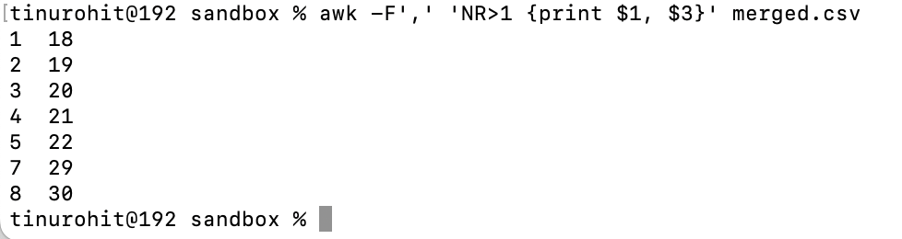

1. Filter lines based on condition

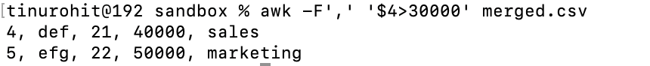

1. String Manipulation

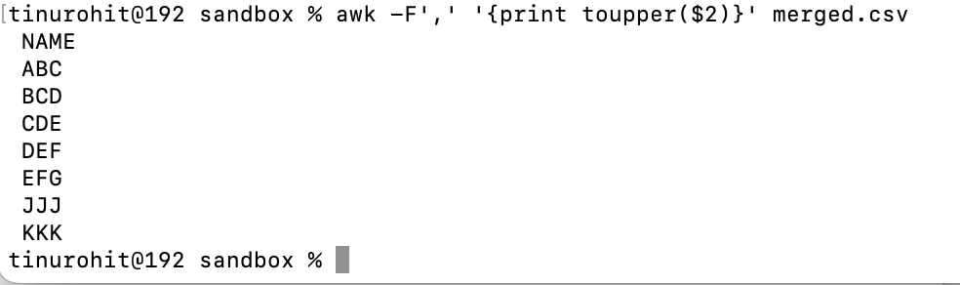

1. Count based on a condition



1. Calculate sum



**SED:**

1. Replace a word globally

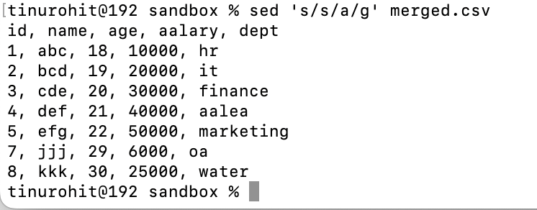

1. Delete lines with pattern

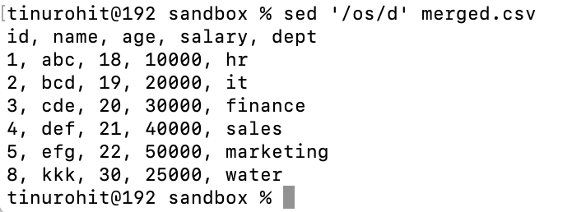

1. Print specific lines

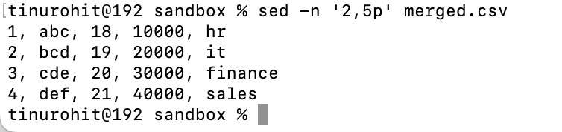

1. Replace a word

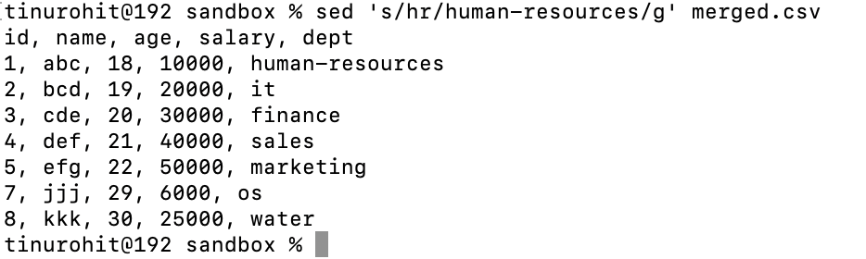

1. To insert a line before pattern

